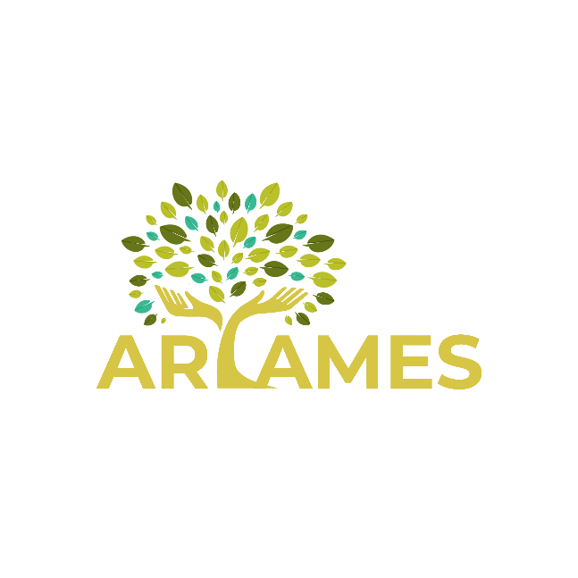
Aryames Contracting Service
1201 Pacific Avenue Suite 600, Tacoma, WA 98402 | 253-954-5510 director@aryames.org
[Date]
[Recipient Name]
[Title]
[Company]
[Street Address]
[City, ST Zip Code]
Dear [Recipient Name]
[If you’re ready to write, select a line or paragraph of tip text and start typing to replace it with your own. Don’t include space to the right of the characters in your selection.]
[It’s easy to match any of the text formatting you see here. On the Home tab of the ribbon, check out the Styles gallery for all styles used in this letter.]
Sincerely,

[Your Name]

