+1-855-594-3792 - www.yesforearlysuccess.org

1201 Pacific Avenue Suite 600, Tacoma, WA. 98402

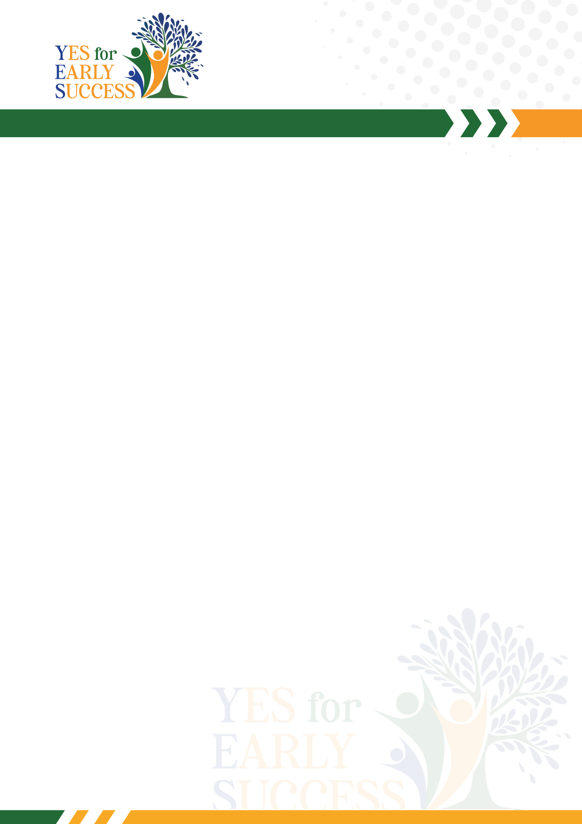Hi Name,

This is the body of the letter.

Sincerely,

Mary Curry

